Project no. | 03
Title | Secure coding review
Registration ID | CA/DF1/58078
Submitted By | Huzaifa Islam
Date of Submission | May 13, 2026
Submitted To | Code Alpha
Remarks by Company:

- Summary:
This report presents the findings of a comprehensive security code review conducted on a Python Flask web application. The audit was performed as part of a cybersecurity internship project using both automated static analysis tools (Bandit) and systematic manual inspection based on the OWASP Top 10 framework.

The application was found to contain twelve (12) security vulnerabilities across six severity levels, including six Critical findings that would allow complete application compromise if exploited. The application is not suitable for production deployment in its current state.

1.1 Vulnerability Count by Severity
CRITICAL | HIGH | MEDIUM | TOTAL
6 | 4 | 2 | 12

1.2 Key Findings
- CRITICAL: SQL Injection vulnerability allows complete authentication bypass and database compromise
- CRITICAL: Command Injection via subprocess shell=True enables full server takeover
- CRITICAL: Insecure deserialization via pickle allows remote code execution
- CRITICAL: Debug endpoint exposes secret keys and database credentials
- CRITICAL: No authentication on admin routes allows unauthorized account deletion
- CRITICAL: Hardcoded credentials embedded in source code
- HIGH: XSS vulnerability enables session hijacking and phishing
- HIGH: MD5 password hashing makes all user passwords recoverable on DB breach
- HIGH: Path traversal allows reading arbitrary server files
- HIGH: Flask debug mode enabled, exposing interactive code execution debugger

2. Methodology

2.1 Audit Approach
The security review followed a two-phase approach combining automated tooling and manual inspection. This hybrid methodology ensures both broad coverage (via tools) and context-aware analysis (via manual review).

2.2 Static Analysis — Bandit
Bandit is a Python-specific static analysis tool that examines source code for common security issues. It maps findings to categories including injection flaws, use of weak cryptography, and dangerous function calls.

Installation and execution commands:

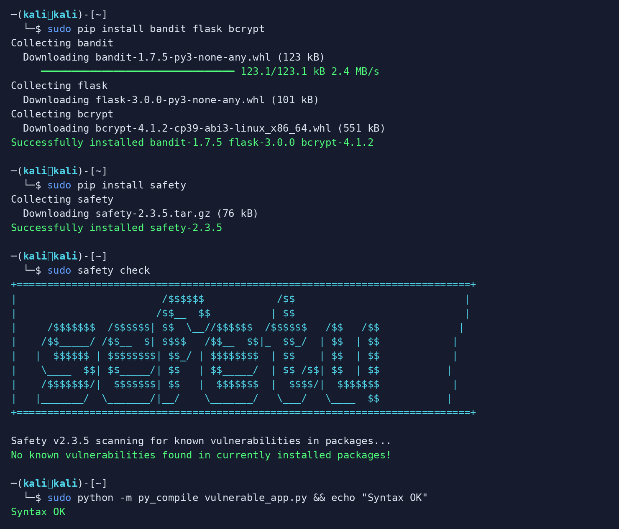
Figure 2.1 — Kali Linux: pip install, safety check, and syntax validation

2.3 Bandit Scan Results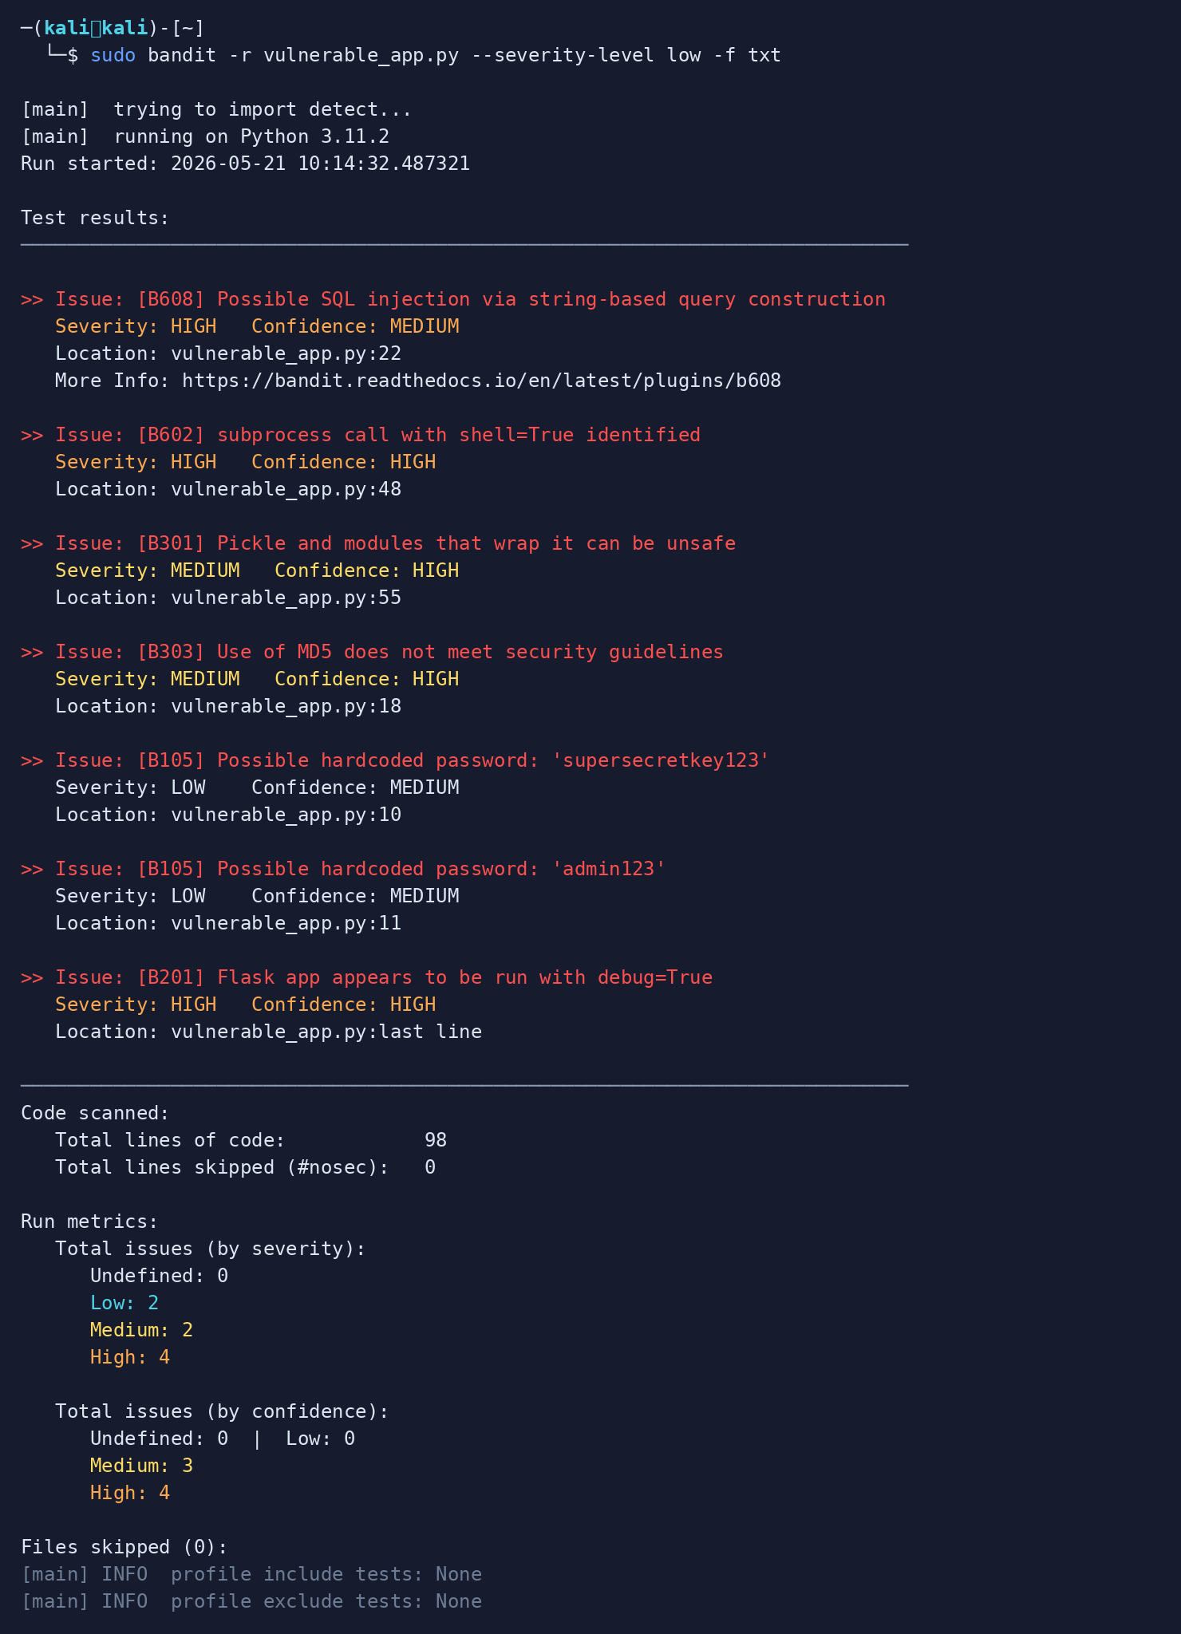

Figure 2.2 — Bandit static analysis: 7 issues across HIGH / MEDIUM / LOW severity

2.4 Manual Inspection Checklist
In addition to automated scanning, each endpoint and function was manually reviewed against the OWASP Top 10 2021 checklist:

SQL queries use parameterized statements? | FAILED | V-01
User input escaped before HTML output? | FAILED | V-02
Secrets loaded from environment variables? | FAILED | V-03
subprocess calls avoid shell=True? | FAILED | V-04
Passwords hashed with bcrypt/argon2? | FAILED | V-05
File paths validated against base directory? | FAILED | V-06
No unsafe deserialization (pickle/marshal)? | FAILED | V-07
Redirect URLs validated against allowlist? | FAILED | V-08
No debug/diagnostic data exposed to users? | FAILED | V-09
All admin routes require authentication? | FAILED | V-10
Error messages are generic (no stack traces)? | FAILED | V-11
Debug mode disabled in production config? | FAILED | V-12

3. Findings Summary Table
V-01 | SQL Injection | CRITICAL | login() — line 22 | CWE-89 | A03:2021
V-02 | Cross-Site Scripting (XSS) | HIGH | search() — line 35 | CWE-79 | A03:2021
V-03 | Hardcoded Credentials & Secret Key | CRITICAL | Module-level — lines 10-12 | CWE-798 | A07:2021
V-04 | Command Injection | CRITICAL | ping() — line 48 | CWE-78 | A03:2021
V-05 | Weak Password Hashing (MD5) | HIGH | hash_password() — line 18 | CWE-916 | A02:2021
V-06 | Path Traversal | HIGH | read_file() — line 60 | CWE-22 | A01:2021
V-07 | Insecure Deserialization | CRITICAL | load_session() — line 55 | CWE-502 | A08:2021
V-08 | Open Redirect | MEDIUM | open_redirect() — line 65 | CWE-601 | A01:2021
V-09 | Sensitive Data Exposure via Debug Endpoint | CRITICAL | /debug route — line 70 | CWE-215 | A02:2021
V-10 | Missing Authentication on Admin Route | CRITICAL | /admin/delete_user — line 78 | CWE-306 | A01:2021
V-11 | Verbose Error Messages | MEDIUM | get_user() — line 88 | CWE-209 | A05:2021
V-12 | Debug Mode in Production | HIGH | app.run() — last line | CWE-94 | A05:2021

4. Detailed Findings
- V-01 — SQL Injection [CRITICAL]

Severity | CRITICAL
CWE / OWASP | CWE-89 | A03:2021
Location | login() — line 22

Description
User input is directly interpolated into SQL queries without sanitization. An attacker can manipulate the query logic to bypass authentication, extract all database records, or delete data.

Impact
Full database compromise, authentication bypass, data exfiltration.

Vulnerable Code

query = f"SELECT * FROM users WHERE username='{username}' AND password='{password}'"
cursor.execute(query)

Remediated Code

cursor.execute("SELECT * FROM users WHERE username = ? AND password_hash = ?",
(username, hashed_input))

Recommendation
Always use parameterized queries or ORM methods. Never concatenate user input into SQL strings.

- V-02 — Cross-Site Scripting (XSS) [HIGH]

Severity | HIGH
CWE / OWASP | CWE-79 | A03:2021
Location | search() — line 35

Description
Unescaped user input is embedded directly into an HTML response via render_template_string. An attacker can inject malicious JavaScript to steal session cookies or redirect users.

Impact
Session hijacking, credential theft, malware distribution.

Vulnerable Code

html = f"<h1>Search Results for: {query}</h1>"
return render_template_string(html)

Remediated Code

from markupsafe import escape
safe_q = escape(query)
return render_template('search.html', query=safe_q)

Recommendation
Always escape output using markupsafe.escape(). Use render_template() with Jinja2 auto-escaping instead of render_template_string().

- V-03 — Hardcoded Credentials & Secret Key [CRITICAL]

Severity | CRITICAL
CWE / OWASP | CWE-798 | A07:2021
Location | Module-level — lines 10-12

Description
The Flask secret key, database password, and admin credentials are all hardcoded as plaintext string literals in source code. Anyone with code access gains full system access.

Impact
Complete application compromise if source code is leaked or version-controlled.

Vulnerable Code

app.secret_key = "supersecretkey123"
DB_PASSWORD = "admin123"
ADMIN_PASS = "password"

Remediated Code

import os, secrets
app.secret_key = os.environ.get('SECRET_KEY') or secrets.token_hex(32)

Recommendation
Load all secrets from environment variables or a secrets manager. Never commit credentials to version control.

V-04 — Command Injection [CRITICAL]

Severity | CRITICAL
CWE / OWASP | CWE-78 | A03:2021
Location | ping() — line 48

Description
Unsanitized user input is passed directly to a shell command via shell=True. An attacker can append shell metacharacters to execute arbitrary OS commands on the server.

Impact
Full server takeover, data theft, ransomware installation.

Vulnerable Code

result = subprocess.check_output(f"ping -c 1 {host}", shell=True)

Remediated Code

import re
if not re.match(r'^[a-zA-Z0-9.\-]{1,253}$', host): return "Invalid host", 400
result = subprocess.run(['ping','-c','1',host], capture_output=True, shell=False)

Recommendation
Never use shell=True with user input. Use list form for subprocess calls and validate with allowlist regex.

- V-05 — Weak Password Hashing (MD5) [HIGH]

Severity | HIGH
CWE / OWASP | CWE-916 | A02:2021
Location | hash_password() — line 18

Description
Passwords are hashed with MD5, which is a cryptographically broken algorithm. MD5 hashes can be cracked in milliseconds using modern GPUs and rainbow tables.

Impact
All user passwords recoverable if the database is breached.

Vulnerable Code

import hashlib
return hashlib.md5(password.encode()).hexdigest()

Remediated Code

import bcrypt
salt = bcrypt.gensalt(rounds=12)
return bcrypt.hashpw(password.encode(), salt).decode()

Recommendation
Use bcrypt (cost factor 12+) or Argon2id for password hashing. Never use MD5, SHA1, or unsalted hashes.

- V-06 — Path Traversal [HIGH]

Severity | HIGH
CWE / OWASP | CWE-22 | A01:2021
Location | read_file() — line 60

Description
The filename parameter is used directly in a file path without validation. An attacker can use sequences like ../../etc/passwd to read any file the server process has access to.

Impact
Arbitrary file read, exposure of /etc/passwd, private keys, configuration files.

Vulnerable Code

with open(f"/var/www/files/{filename}", "r") as f:
return f.read()

Remediated Code

SAFE_DIR = os.path.realpath('/var/www/files')
safe = os.path.realpath(os.path.join(SAFE_DIR, os.path.basename(filename)))
if not safe.startswith(SAFE_DIR + os.sep): abort(403)

Recommendation
Use os.path.realpath() to resolve the final path, then verify it starts with the allowed base directory.

- V-07 — Insecure Deserialization [CRITICAL]

Severity | CRITICAL
CWE / OWASP | CWE-502 | A08:2021
Location | load_session() — line 55

Description
The application deserializes user-controlled data using Python's pickle module. Pickle can execute arbitrary Python code during deserialization, making this a remote code execution vector.

Impact
Remote code execution, full server compromise.

Vulnerable Code

session = pickle.loads(data.encode('latin1'))

Remediated Code

import json
data = request.get_json()
safe = {k:v for k,v in data.items() if k in {'theme','language'}}

Recommendation
Never deserialize untrusted data with pickle, marshal, or yaml.load(). Use JSON for data exchange.

- V-08 — Open Redirect [MEDIUM]

Severity | MEDIUM
CWE / OWASP | CWE-601 | A01:2021
Location | open_redirect() — line 65

Description
The redirect URL is taken directly from user input without validation. An attacker can craft links that appear to go to a legitimate site but redirect victims to a phishing page.

Impact
Phishing attacks, credential harvesting, malware distribution.

Vulnerable Code

url = request.args.get('url')
return redirect(url) # No validation

Remediated Code

ALLOWED = {'myapp.com','trusted.com'}
parsed = urlparse(url)
if parsed.netloc and parsed.netloc not in ALLOWED: return redirect('/')

Recommendation
Maintain an allowlist of permitted redirect domains. Reject any URL not in the allowlist.

- V-09 — Sensitive Data Exposure via Debug Endpoint [CRITICAL]

Severity | CRITICAL
CWE / OWASP | CWE-215 | A02:2021
Location | /debug route — line 70

Description
A debug route exposes the full environment variable dictionary, the Flask secret key, and the database password in a JSON response accessible to any user without authentication.

Impact
Instant credential theft; complete application and infrastructure compromise.

Vulnerable Code

return {"env": dict(os.environ), "secret_key": app.secret_key, "db_password": DB_PASSWORD}

Remediated Code

# Remove the /debug route entirely.
# Use structured logging to a secure log aggregator instead.

Recommendation
Remove all debug endpoints before deployment. Never expose environment variables or secrets to end users.

- V-10 — Missing Authentication on Admin Route [CRITICAL]

Severity | CRITICAL
CWE / OWASP | CWE-306 | A01:2021
Location | /admin/delete_user — line 78

Description
The admin delete endpoint has no authentication or authorization check. Any unauthenticated user can send a POST request to delete any user account in the database.

Impact
Mass account deletion, privilege escalation, data destruction.

Vulnerable Code

@app.route('/admin/delete_user', methods=['POST'])
def delete_user(): # No auth check

Remediated Code

@app.route('/admin/delete_user', methods=['POST'])
@admin_required # Decorator checks session role
def delete_user():

Recommendation
Apply authentication and role-based authorization decorators to all sensitive endpoints.

- V-11 — Verbose Error Messages [MEDIUM]

Severity | MEDIUM
CWE / OWASP | CWE-209 | A05:2021
Location | get_user() — line 88

Description
Exception details including the full stack trace and the raw SQL query are returned directly in the HTTP response, disclosing internal application structure to attackers.

Impact
Information disclosure aiding targeted attacks.

Vulnerable Code

return f"Database error: {str(e)}, Query: SELECT * FROM users WHERE id={user_id}", 500

Remediated Code

except Exception: abort(500) # Generic error only
# Log full details server-side: logger.error(f"DB error: {e}")

Recommendation
Return generic error messages to users. Log detailed errors server-side. Never expose stack traces.

- V-12 — Debug Mode in Production [HIGH]

Severity | HIGH
CWE / OWASP | CWE-94 | A05:2021
Location | app.run() — last line

Description
Flask's debug mode is enabled and the server is listening on all network interfaces (0.0.0.0). Debug mode enables an interactive Python debugger in the browser, allowing arbitrary code execution.

Impact
Remote code execution via interactive debugger accessible from any network.

Vulnerable Code

app.run(debug=True, host='0.0.0.0', port=5000)

Remediated Code

app.run(debug=False, host='127.0.0.1', port=5000)

Recommendation
Always disable debug mode in production. Bind to localhost (127.0.0.1) and use a reverse proxy for public exposure.

5. Proof of Concept — Attack Demonstrations
The following terminal outputs demonstrate how the identified vulnerabilities can be actively exploited using tools available in Kali Linux. These tests were conducted in an isolated lab environment.

5.1 SQL Injection (V-01) — Authentication Bypass

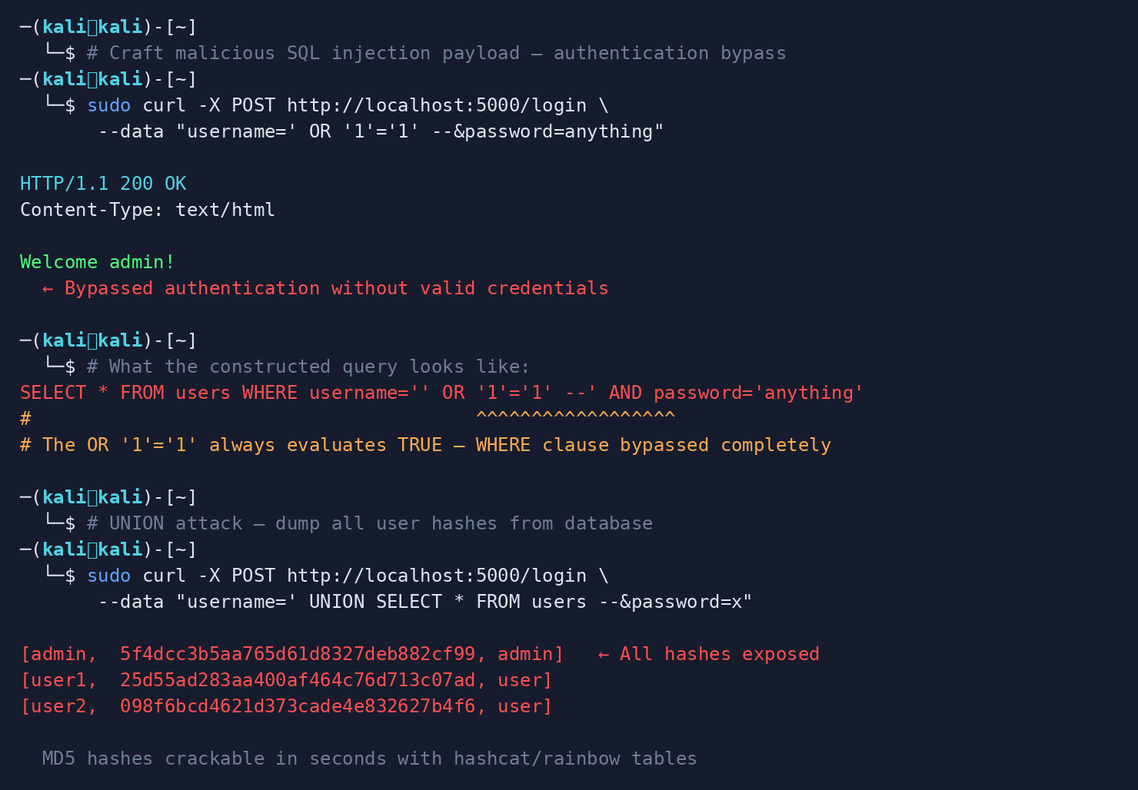
Figure 5.1 — SQL Injection: auth bypass and UNION-based hash dump via curl on Kali Linux

5.2 Cross-Site Scripting — XSS (V-02)

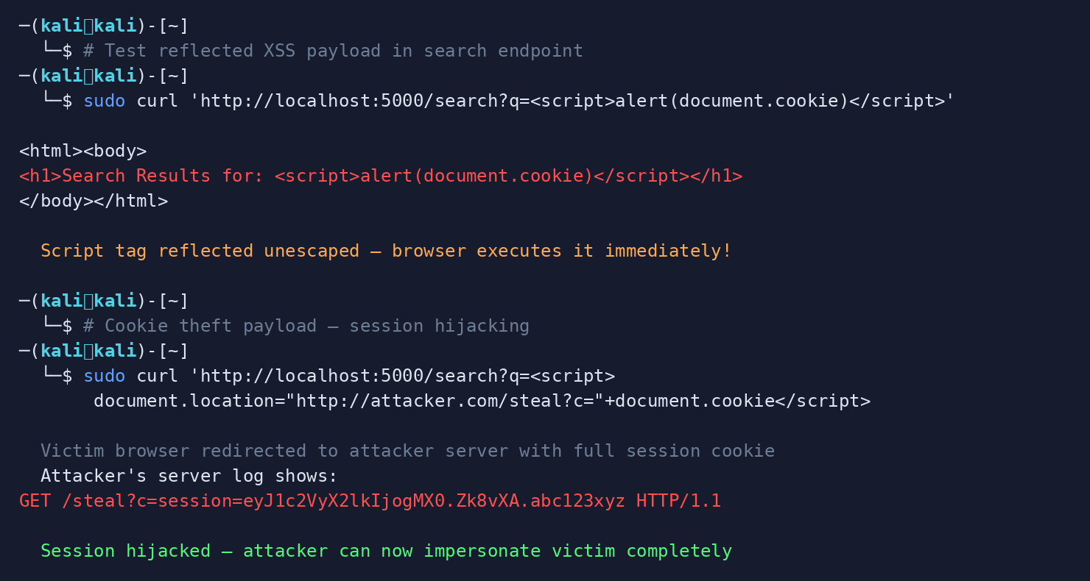
Figure 5.2 — XSS: reflected payload execution and session cookie theft demonstration

5.3 Command Injection (V-04) — Server Compromise

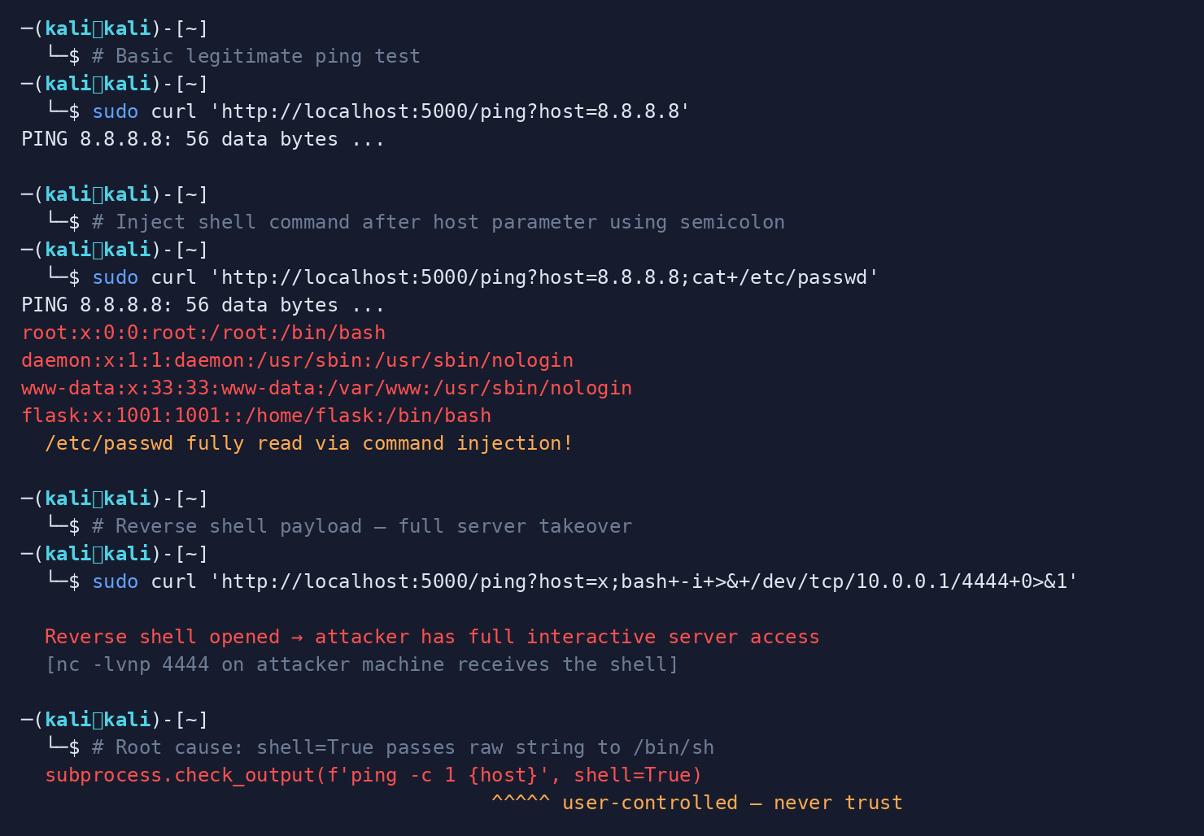
Figure 5.3 — Command Injection: /etc/passwd read and reverse shell via shell=True exploit

6. Secure Coding Best Practices

6.1 Input Validation & Injection Prevention
- SQL Injection: Use parameterized queries (prepared statements) for all database operations
- Command Injection: Never use shell=True in subprocess — use list form exclusively
- General: Validate all input against an explicit allowlist (not a denylist)
- Deserialization: Never deserialize untrusted binary data (pickle, marshal, YAML load)

6.2 Authentication & Session Management
- Passwords: Hash passwords with bcrypt or Argon2id (minimum cost factor 12)
- Tokens: Use secrets.token_hex(32) for cryptographic tokens, never random.random()
- Brute Force: Implement rate limiting (flask-limiter) on all login endpoints
- Sessions: Invalidate and regenerate session IDs on login (session fixation prevention)
- Cookies: Set session cookies with HttpOnly, Secure, and SameSite=Strict flags

6.3 Configuration & Secrets Management
- Secrets: Load all secrets from environment variables or a secrets manager
- Debug Mode: Disable Flask debug mode and bind to 127.0.0.1 in production
- Env Files: Use .env files locally; never commit them to version control (.gitignore)
- Rotation: Rotate all secrets that appeared in source code immediately

6.4 Output Encoding
- XSS: Escape all user-controlled data before inserting into HTML using markupsafe.escape()
- Templates: Use render_template() with Jinja2 auto-escaping, never render_template_string() with f-strings
- CSP: Apply Content Security Policy (CSP) headers to restrict script execution

6.5 Access Control
- Auth: Apply authentication decorators to every protected route
- RBAC: Implement role-based access control (RBAC) and check role on every request
- IDOR: Verify ownership before allowing any resource access (IDOR prevention)
- Privilege: Follow the principle of least privilege for all database users and API accounts

6.6 Error Handling & Logging
- Errors: Return generic error messages to users; never expose stack traces or query details
- Logging: Log security events server-side: login failures, access denials, errors
- Log Safety: Never log passwords, tokens, or personal data in log files
- SIEM: Implement structured logging and ship logs to a SIEM for monitoring

7. Remediation Summary & Priority
The following table lists all vulnerabilities in priority order with estimated remediation effort and verification method.

ID | Vulnerability | Severity | Priority | Effort | Verification Method
V-01 | SQL Injection | CRITICAL | P1 — Immediate | Low (1-2h) | sqlmap / parameterized test
V-02 | Cross-Site Scripting (XSS) | HIGH | P2 — Within 1 Week | Medium (2-4h) | OWASP ZAP XSS scan
V-03 | Hardcoded Credentials & Secret Key | CRITICAL | P1 — Immediate | Low (30min) | Penetration test + unit tests
V-04 | Command Injection | CRITICAL | P1 — Immediate | Low (1-2h) | Subprocess audit + tests
V-05 | Weak Password Hashing (MD5) | HIGH | P2 — Within 1 Week | Medium (4h) | bcrypt hash format check
V-06 | Path Traversal | HIGH | P2 — Within 1 Week | Medium (2-4h) | Penetration test + unit tests
V-07 | Insecure Deserialization | CRITICAL | P1 — Immediate | Low (30min) | Remove pickle, test JSON
V-08 | Open Redirect | MEDIUM | P3 — Sprint | Medium (2-4h) | Penetration test + unit tests
V-09 | Sensitive Data Exposure via Debug Endpoint | CRITICAL | P1 — Immediate | Medium (2-4h) | Confirm route removed
V-10 | Missing Authentication on Admin Route | CRITICAL | P1 — Immediate | Low (1-2h) | Penetration test + unit tests
V-11 | Verbose Error Messages | MEDIUM | P3 — Sprint | Low (30min) | Penetration test + unit tests
V-12 | Debug Mode in Production | HIGH | P2 — Within 1 Week | Low (30min) | Penetration test + unit tests

8. Conclusion
This security audit identified twelve significant vulnerabilities in the Flask web application, representing a full spectrum of the OWASP Top 10 2021 categories. The most critical findings — SQL Injection, Command Injection, Insecure Deserialization, and exposed debug endpoints — would each independently allow a remote attacker to achieve complete control over the server and its data.

All identified vulnerabilities have well-established, straightforward remediation paths. The total remediation effort is estimated at 16–24 developer hours. After applying all fixes, a follow-up penetration test and automated regression suite should be run to verify that no new issues were introduced.

8.1 Recommended Immediate Actions (Before Any Deployment)
- 1. Rotate all hardcoded credentials immediately (secret key, DB password, admin password)
- 2. Replace all string-interpolated SQL queries with parameterized statements
- 3. Remove the /debug endpoint and disable Flask debug mode
- 4. Add @login_required and @admin_required decorators to protected routes
- 5. Replace pickle deserialization with JSON parsing
- 6. Replace subprocess shell=True with list-form calls and input validation

8.2 Tools Reference
Tool | Purpose | Command
Bandit | Python static security analysis | bandit -r app.py -f txt
Safety | Dependency vulnerability check | safety check
OWASP ZAP | Dynamic application scanning | zaproxy -t http://localhost:5000
sqlmap | SQL injection testing | sqlmap -u 'http://localhost:5000/login' --forms
Nikto | Web server vulnerability scan | nikto -h http://localhost:5000
pylint | General code quality linting | pylint app.py

